Facebook Posts - Lyme Disease
English | Image
Going camping this long weekend? Learn how to protect yourself from Lyme disease. ontario.ca/lyme | 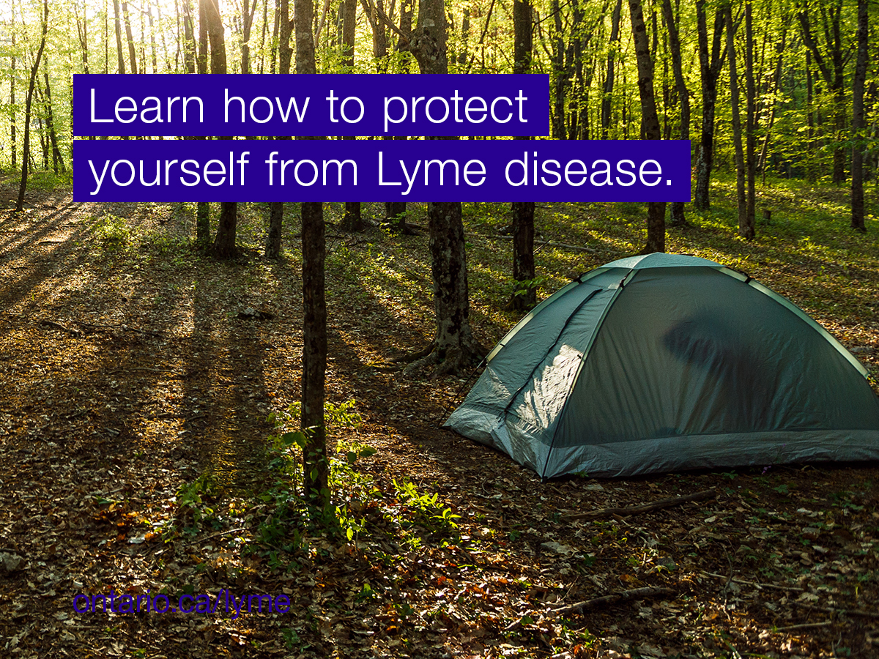
Insect repellant, body checks, covering up…know the tips and tricks for avoiding tick bites. ontario.ca/lyme | 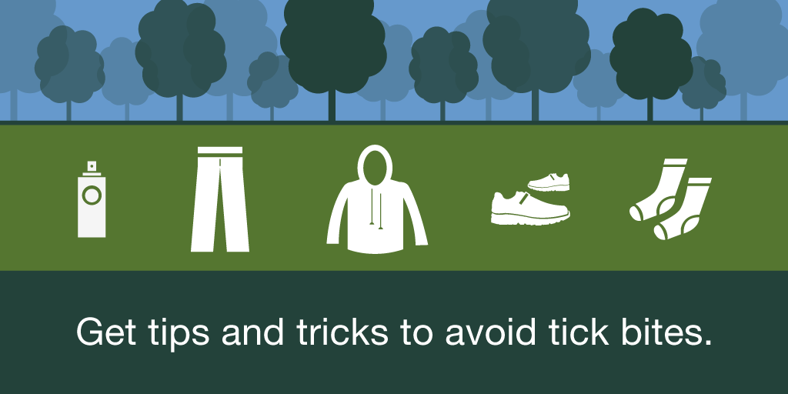
Prevent tick bites when working outdoors. ontario.ca/lyme | 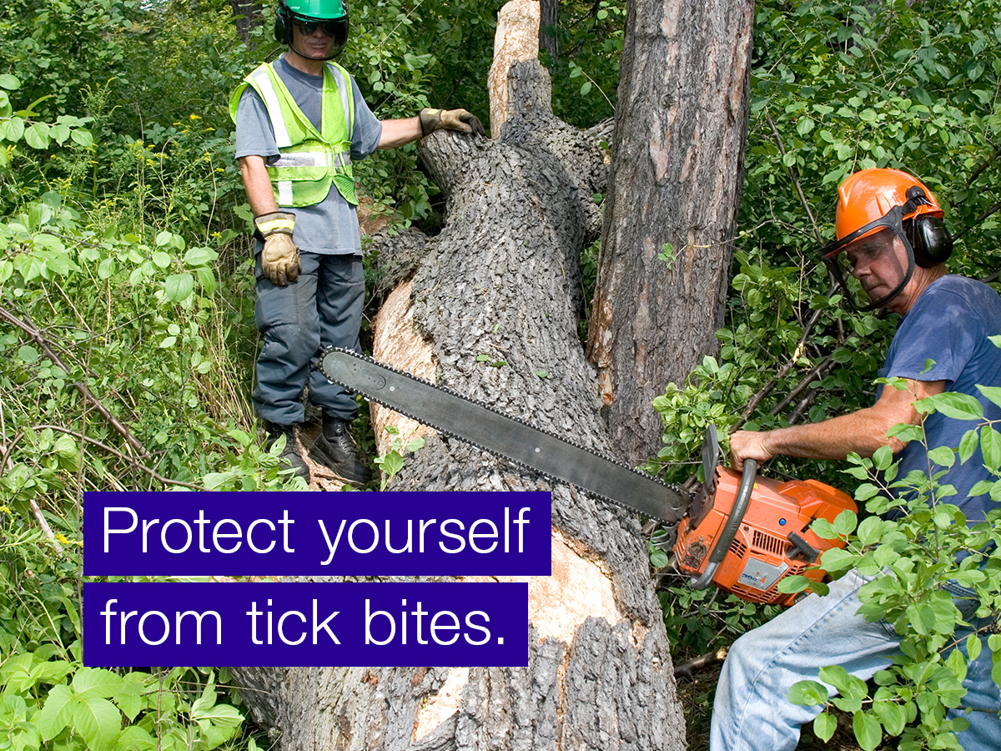
Going to the cottage this weekend? If bringing your pet, make sure to check them for ticks. Blacklegged ticks may carry Lyme disease, attach to your furry one and then may reattach to you or others with you. ontario.ca/lyme | 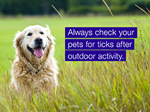

Twitter Posts – Lyme Disease

English | Image
Bitten by a tick? Don’t panic. Learn how to remove it here: ontario.ca/lyme | 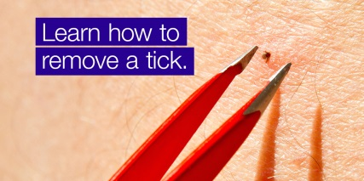
Keep ticks off with insect repellent containing DEET this weekend. ontario.ca/lyme #Lymedisease | 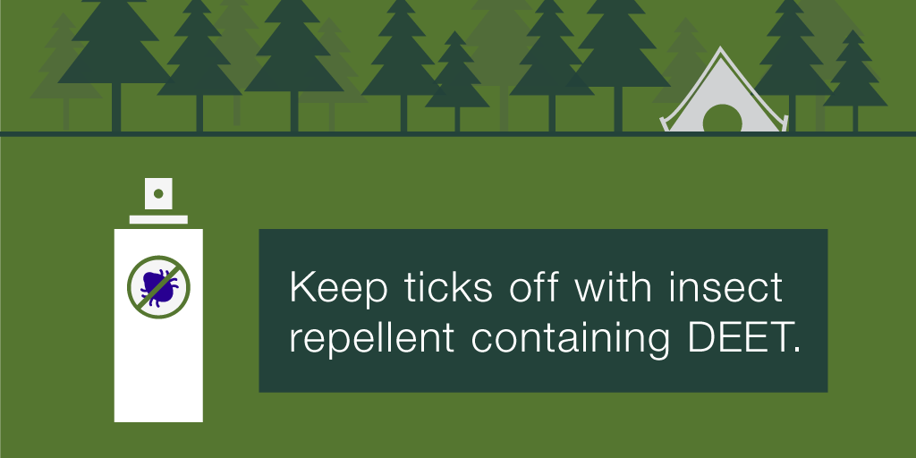
#LymeDisease: Know the signs. The earlier you treat it, the better. | 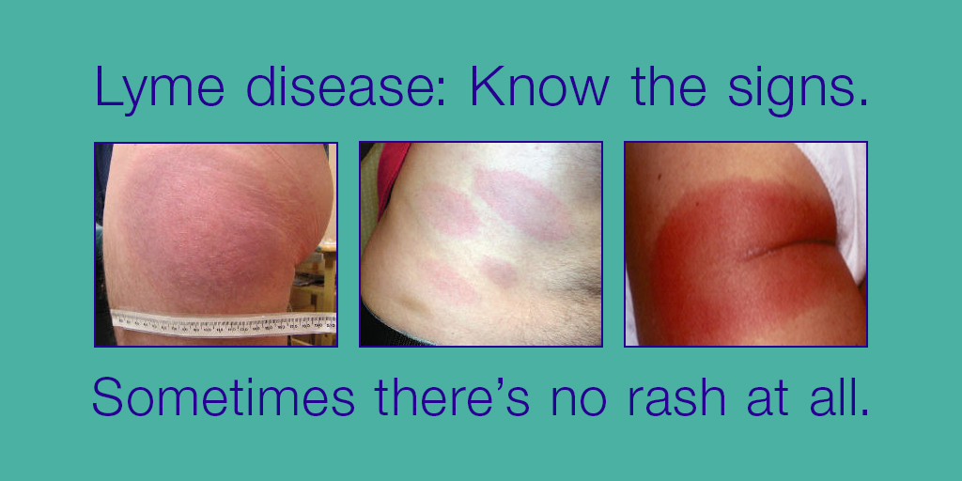
Headache, fatigue and facial paralysis are some symptoms of #Lymedisease ontario.ca/lyme | 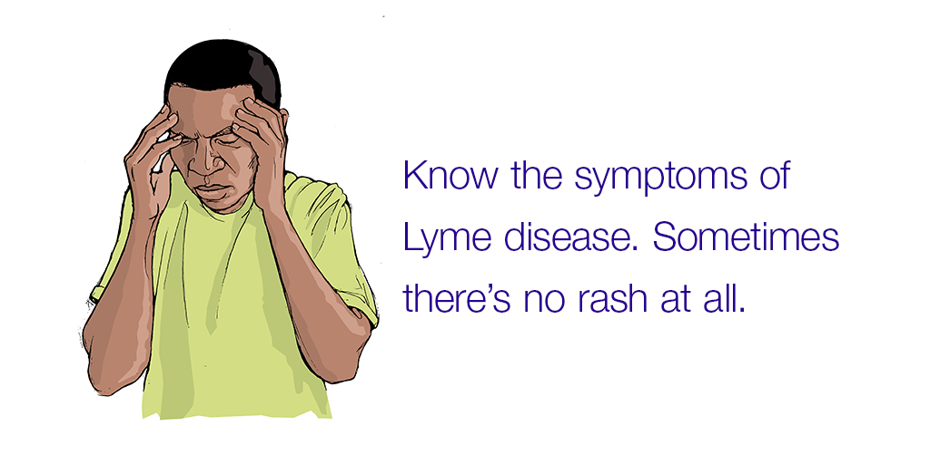
Do the tick check! Get tips and tricks to avoid tick bites: ontario.ca/lyme #lymedisease | 